

**Healthcare**

**Software Design Document**

– Hanoi, September 2022 –

**I. Overview**

**1. Code Packages/Namespaces**

*[Provide the package diagram for each sub-system. The content of this section including the overall package diagram, the explanation, package and class naming conventions in each package. Please see the sample and description table format below – following Java project naming convention]*



***Package descriptions & package class naming conventions***

|  |  |  |
| --- | --- | --- |
| **No** | **Package** | **Description** |
| *01* | *<Package name>* | *<Description of the package>*  *<Class naming convention>* |
| *02* |  |  |

**2. Coding Conventions**

**II. Code Designs**

**1. <Feature/Function Name1>**

*[Provide the detailed design for the function <Feature/Function Name1>. It include Class Diagram, Class Specifications, and Sequence Diagram(s)]*

**a. Class Diagram**

*[This part presents the class diagram for the relevant feature]*



**b. Class Specifications**

*[Provide the description for each class and the methods in each class, following the table format as below]*

***XYZ Class***

*[Provide the detailed description for the class methods]*

|  |  |  |
| --- | --- | --- |
| **No** | **Method** | **Description** |
| *01* | *<method name>* | *<Description of the method, including the inputs, outputs & internal method processing>* |
|  |  |  |

***ABC Class***

***Class Methods***

*[Provide the detailed description for the class methods]*

|  |  |  |
| --- | --- | --- |
| **No** | **Method** | **Description** |
| *01* | *<method name>* | *<Description of the method, including the inputs, outputs & internal method processing>* |
|  |  |  |

**c. Sequence Diagram(s)**

*[Provide the sequence diagram(s) for the feature, see the sample below]*



**d. Database queries**

*[Provide the detailed SQL (select, insert, update...) which are used in implementing the function/screen]*

**2. <Feature/Function Name2>**

…

**III. Database Design**

**1. Database Schema**

*[Provide the tables relationship like example below – following MySQL database naming convention]*

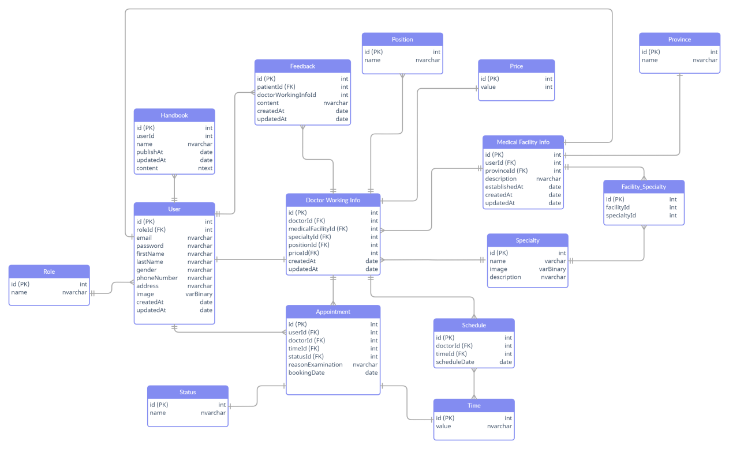

**2. Table Description**

|  |  |  |
| --- | --- | --- |
| **No** | **Table** | **Description** |
| *01* | *<Table name>* | *<Description of the table>*  *- Primary keys: <<list of primary key fields>>*  *- Foreign keys: <<list of foreign key fields>>* |
| *02* |  |  |